

Cliffsend Rewilding
Draft V4.0 April 2023

Cliffsend Parish Council

Overview
Cliffsend is situated in the district of Thanet, west of Ramsgate and south of Minster, overlooking Pegwell Bay. The area is of historic and geological importance due to it being the landing site of Roman invasion fleets, Vikings Hengist and Horsa and St Augustine who brought Christianity to Britain.
Where the coast meets the land a unique geological feature called the Thanet Formation, a strategic interval in geology, is situated.
Cliffsend has currently around 2,000 residents and is expanding with housing developments to the north and west of the village. We expect the demographic to alter slightly due to the increase of families with young children moving into the new, affordable housing stock.

Goals and Objectives
- To improve the aesthetic appearance of Cliffsend.
- To improve biodiversity.
- To encourage interest and participation by all sectors/ages of the community in the improvement and sustainability of green spaces.
- To educate and share knowledge within the community.

How will this be achieved?
- Participating in national events such as Parish in Bloom.
- Identifying areas for green redevelopment.
- The creation of a schedule of works and timelines.
- Actively engaging with internal and external stakeholders.
- Identifying and pursuing sources of funding and assistance.
- The creation of a Working Group to include members of the community.

Identified areas for attention
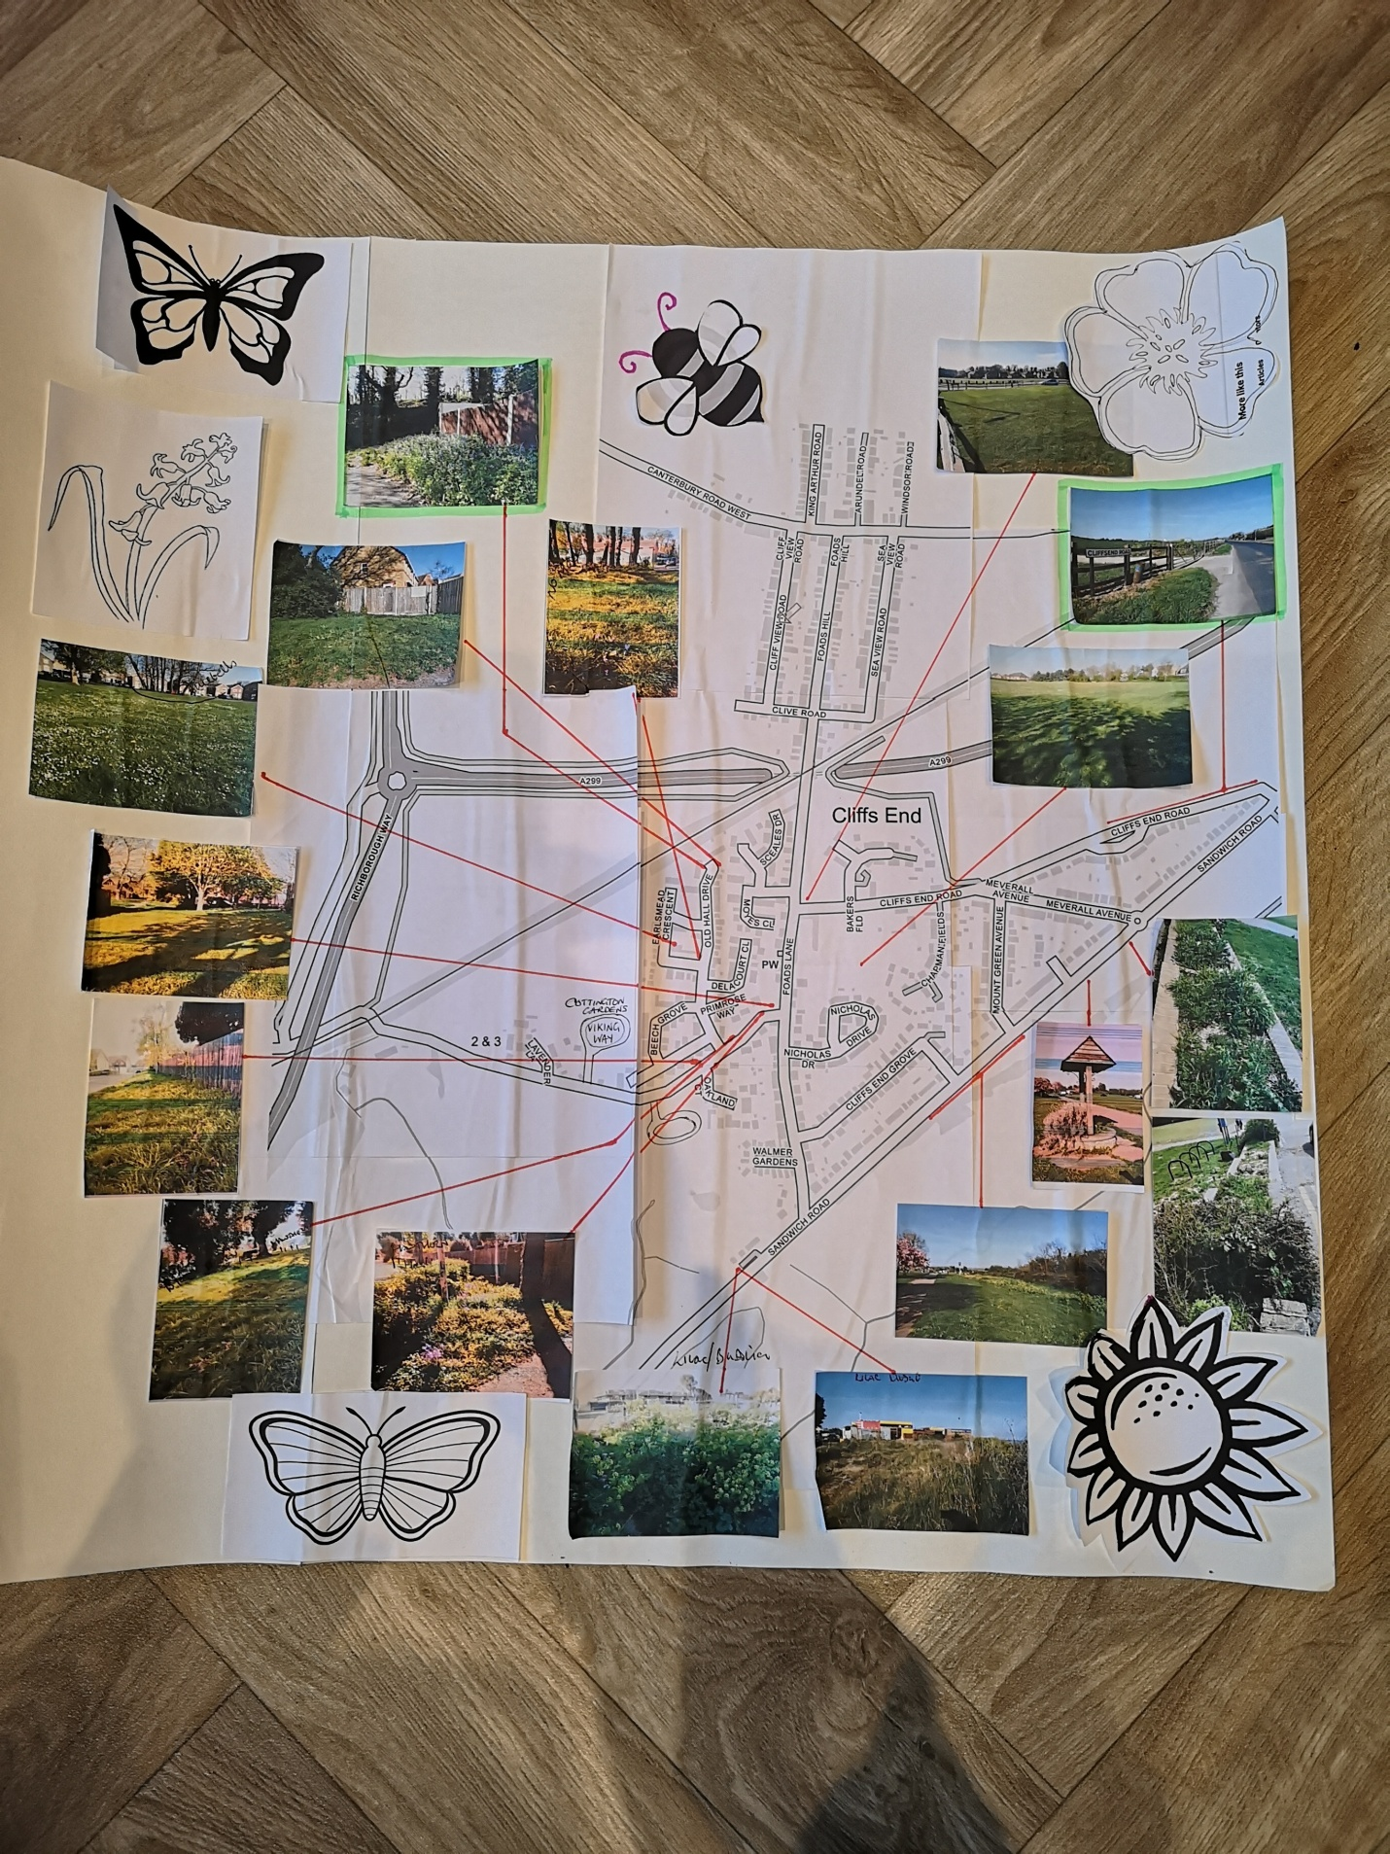

Schedule
Key: Completed, In Progress
Area | Action | When | Volunteers
Land by Jet garage | Plant trees, | When trees become available
Primrose Way | Rebuild planters, plant native bublbs. | Ongoing | Judith / James L
Hugin Green  Sandwich Road  Wishing Well  Public Entrance | Increase native narcissus population.  Plant trees.  Replant and maintain  Replant borders with drought resilient pollinators | Autumn 2022  When trees become available. Autumn/Winter 2022  April 2022  April 2022 | Christine  Judith
Baker’s Field | Plant fruit trees particular to Kent | When trees and funding becomes available
Meadow | Allow parts to grow wild and create wildflower strips | May 2022 | Judith
Cliffsend Road | Leave verges | May 2022
Cottington Road | Create wildflower strips | May 2022 | Anne, Judith
Village Green  Area Opposite Village Hall | Remove elder and other old shrubs. Replace with new. Possibly plant native bulbs. | 2023
Earlsmead | Add more spring bulbs to bluebell patch. Clearly define area with signage.  Possible addition of a limited number of trees. | 2023 | James L
Park / Playground | Reduce ivy and brambles.  Pile up branches and debris.  Lay bark chips  Build and site bug hotels.  Plant sunflowers | Ongoing  Ongoing  Ongoing  May2022  May2022 | Judith, Gary, Jim, Alison, Tash, Chloe,  Judith, Karine, Mark, Youth Justice  Judith, Gary  Lisa’s Under 5’s
Community | Build bird, bat and hedgehog houses | Autumn 2022 | Parents and children of the community

Appendix 1 – Ownership of identified sites
Marjorie Chapman Meadow – Robert Chapman. Rented to Cliffsend on 125 year rental agreement.
Land by Jet Garage – Thanet District Council
Primrose Way – Kent County Council
Hugin Green – Thanet District Council
Bakers Field – Millwood Homes
Cliffsend Road Green – Thanet District Council
Village Green – Kent County Council
Earlsmead – Crown Estate
Park/Playground – Thanet District Council

Appendix 2 – Potential sources of funding
Community donations
Local business donations
TDC grants
KCC grants
Developers of housing
NetworkRail and/or contractors (BAM Nuttall)
Kent Community Foundation
Urban Tree Challenge Fund

